Smart Waste Management System Using IBM Watson Services

TEAM POCHINKI

* Madisetty Eshwar
* Gowtham Mohan
* Kolluru Sri Harsha

Objective

To develop a smart garbage bin which will intimate the particular authority, if the garbage bin is about to fill full.

Problem Statement:

In many places, the Municipal garbage bins are overflowing and they are not cleaned at proper time. As a result of which the consequences are severe. It includes overflow of garbage which results in land pollution, spread of diseases, also it creates unhygienic conditions for people, and ugliness to that place

Hardware used:

**Module1: Sensor**

Ultrasonic Sensor

An **Ultrasonic sensor** is a device that can measure the distance to an object by using sound waves. By recording the elapsed time between the sound wave being generated and the sound wave bouncing back, it is possible to calculate the distance between the **sonar sensor** and the object.

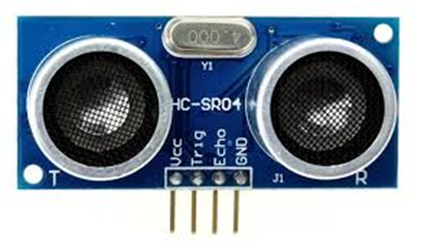

**HC-SR04 Sensor Features**

* Operating voltage: +5V
* Theoretical  Measuring Distance: 2cm to 450cm
* Practical Measuring Distance: 2cm to 80cm
* Accuracy: 3mm
* Measuring angle covered: <15°
* Operating Current: <15mA
* Operating Frequency: 40Hz

**Module2: Micro Controller**

NodeMcu – ESP8266

**NodeMcu** is an open source IOT platform. It includes firmware which runs on the ESP8266 Wi-fi Soc from Express if Systems, and hardware which is based on the ESP-12 module. It is an highly integrated chip designed to provide full internet connectivity in a small package.

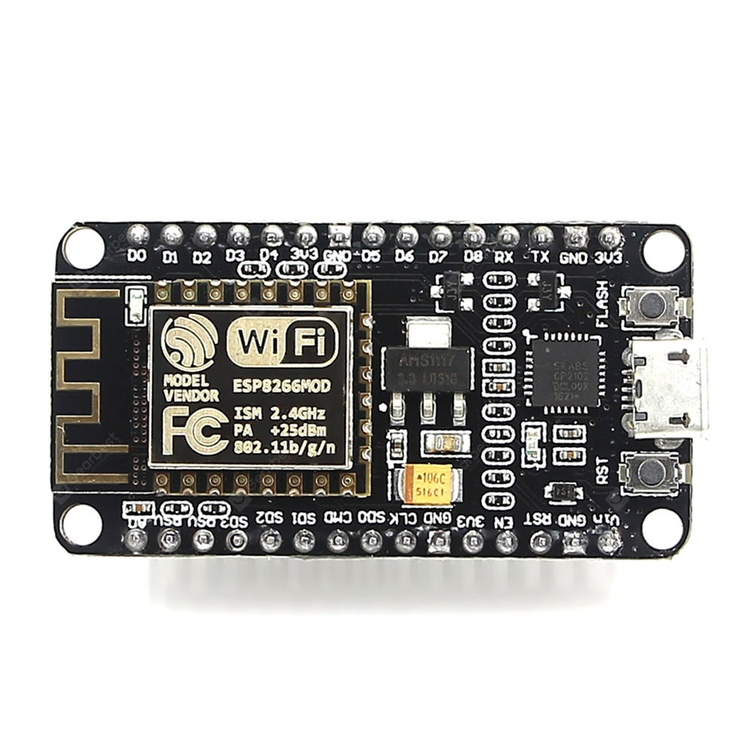

**Features**

*Arduino-like (software defined) hardware IO.

*Can be programmed with the simple and powerful Lua programming language or Arduino IDE.

*USB-TTL included, plug & play.

*10 GPIOs D0-D10, PWM functionality, IIC and SPI communication, 1-Wire and ADC A0 etc. all in one board.

*Wi-fi networking (can be used as access point and/or station, host a web server), connect to internet to fetch or upload data.

*Event-driven API for network applications.

*PCB antenna.

**Module3: Location Tracker**

GPS Module: GY-GPS6MU2

The NEO-6M GPS module is a well-performing complete GPS receiver with a built-in 25 x 25 x 4mm ceramic antenna, which provides a strong satellite search capability. With the power and signal indicators, you can monitor the status of the module. The Ublox GPS module has serial TTL output, it has four pins: TX, RX, VCC, and GND.

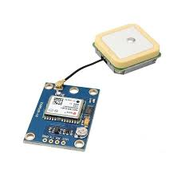

#### **Features:**

1. 5Hz position update rate
2. Operating temperature range: -40 TO 85°CUART TTL socket
3. EEPROM to save configuration settings
4. Rechargeable battery for Backup
5. The cold start time of 38 s and Hot start time of 1 s
6. Supply voltage: 3.3 V
7. Configurable from 4800 Baud to 115200 Baud rates. (default 9600)
8. SuperSense ® Indoor GPS: -162 dBm tracking sensitivity
9. Support SBAS (WAAS, EGNOS, MSAS, GAGAN.

|  |
| --- |
| NODEMCU |

|  |
| --- |
| NODERED |

|  |
| --- |
| IBM CLOUD |

|  |
| --- |
| APP |

**Block Diagram :**

|  |
| --- |
| SENSOR |

**Future scope:**

This project being a part of IOT, may be influential in many ways like in the field of agriculture and water related technical works. This smart garbage bin helps authorities to clean the garbage as soon as possible so that we can avoid unhealthy environments and prevents pollution.

**Conclusion:**

By designing the Smart Garbage Bin we could able to clean the garbage on time by avoiding it from over flow and maintain a healthy environment. Thereby we can prevent the diseases which are produced due to overflow of garbage bins.